5. Significance/Project goals:
The southwestern United States experienced an extended drought from 1999-2002 which led to widespread coniferous tree mortality. Piñon-juniper (PJ) woodlands, which occupy 24 million ha throughout the Southwest, were extremely vulnerable to this drought. An abrupt die-off of 40 to 95% of piñon pine (Pinus edulis) and 2-25% of juniper (Juniperus monosperma) across 1.5 million ha triggered rapid and extensive changes in the structure of PJ woodlands with potentially large, yet unknown, consequences for ecosystem services and feedbacks between the carbon cycle and climate system. Given the spatial extent of PJ woodlands (3rd largest biome in the US) and climatic predictions of increased frequency and intensity of drought in the region, it is crucial to understand the consequences of these disturbances on regional carbon and energy dynamics, biogeochemical processes and atmospheric CO₂. The overall objective of our research was to quantify what impact widespread mortality of piñon trees has for carbon and water cycling in PJ woodlands. Our specific objectives for this proposal were: 1) Quantify the carbon, water and energy exchange trajectory after mortality in PJ woodlands; 2) Determine the mechanisms controlling the response and recovery of ecosystem production and respiration processes following large-scale piñon mortality; 3) Use the relationships we measure between ecosystem structure and function PJ woodlands recover from mortality to scale the results of our study up to the regional scale.

6. Scientific Accomplishments:
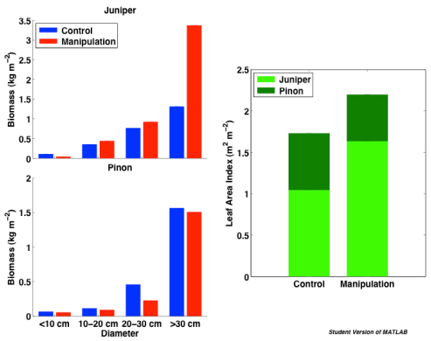
A. Experimental manipulation
- As proposed, we established a new flux tower site in a piñon-juniper woodland 5 km (34.45 N, -106.21 W) from the existing piñon-juniper flux tower (34.33 N, -106.24 W, operational since 2007) that served as the control site for this experiment. Biomass was similar between the control tower site and site to be girdled prior to treatment (Figure 1).
- The new tower has been collecting microclimate, and surface carbon, water and energy data since early February 2009. In Sept 2009, we girdled (severed the phloem) 1632 piñon trees, all > 7 diameter breast height (dbh) in a 4 ha area in the fetch of the new tower (Figure 2). Flux footprint analyses following the protocol outlined in Fox et al. (2008) to calculate the flux source area using 640 days of eddy covariance data indicate the maximum source weights for both day and night periods that contribute to the tower flux are concentrated in the treatment (Figure 2).
Figure 1. Biomass and LAI comparison between girdled site pre-treatment and control.
- The girdled trees were chlorotic by November, dead by April, and lost their needles by late July. We used a temporally dense series of 22 RapidEye scenes over both the control and girdled sites to determine how soon after girdling, satellites were able to detect a change in forest health. The Normalized Difference Red-Edge index (NDRE) that is sensitive to changes in foliar chlorophyll a+b was able to detect stress in the girdled trees 13 days after girdling, which was 12-16 days earlier than the indices traditionally used for satellite based forest health monitoring (Normalized Difference Vegetation Index(NDVI) ) (Eitel et al. 2011).
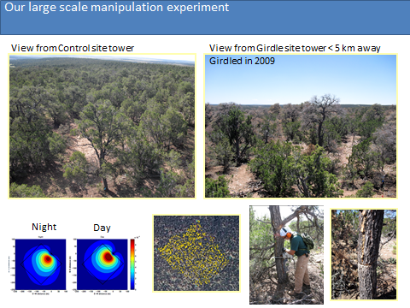
- Other instrumentation at these sites includes: three soil pits under piñon, juniper and open cover types with soil moisture and temperature probes at three depths (5, 20, 40 cm) in each site, soil heat flux plates in each pit installed at 5 cm; sap flow probes in 5 small piñon, 5 large piñon, and 5 juniper trees at both the control and girdled site (2 per tree); Automated soil respiration systems (with 4 chambers each) 2009 in both the control and girdled site that measure fluxes every 30minutes, 24 hours per day; net radiation and its components, air temperature and relative humidity, photosynthetically active radiation (PAR), heat flux plates.
Figure 2. The top two images are views from the towers at the PJ control and girdled sites. In Sept 2009, 1632 piñon trees were girdled (bottom 3 right images) by severing the phloem with a chain saw. The bottom two left images are calculated flux source weight contributions of day and night fluxes in the tower fetch at the girdled tower site. Greater than 90% of the tower fluxes are coming from within the treated area in both day and night.
Control site in 2009
B. Impact of piñon mortality on ecosystem-atmosphere carbon and water exchange
- An initial comparison between control and manipulation site net ecosystem exchange (NEE), gross primary productivity (GPP) and ecosystem respiration (Re) observations clearly indicated there was considerable inter-site variability prior to treatment and inter-annual variability throughout the experiment (Figure 3). As we would expect given the close proximity of these two sites the differences in environmental drivers is minimal, however, prior to girdling the manipulation site is a stronger carbon sink. The most likely cause of this difference is the greater abundance of large junipers at the manipulation site, and based on allometric relationships this resulted in a c. 20% higher LAI, relative to the control site (Figure 1).
Figure 3. Daily Net ecosystem exchange (NEE), Gross Primary Productivity (GPP) and Ecosystem respiration (Re) for both the control and girdled sites from Feb 2009-Oct 2011.
- Although total precipitation per year was similar for each year, the timing of precipitation early in 2010 resulted in a much more active early growing season compared with previous years and 100% greater carbon sequestration. This highlights the need for a control site to compare with the manipulation site, as any simple comparison between before- and after-treatment at a single site would be difficult with such large inter-annual variation.
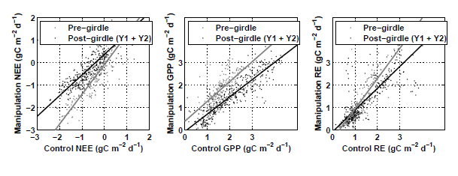
- We used two approaches to correct for the inter-site variability in NEE, GPP and Re. Our first approach was to use the regression relationship between the control and manipulation site daily fluxes established prior to girdling to normalize the observations from the control site and bring them into line with those observed at the manipulation site. For NEE this worked well, the quality of the regression relationship was high, with limited scatter (Figure 4). The effectiveness of this approach is reflected in the comparison of cumulative NEE at the two sites for six months prior to girdling, when there is very good agreement, effectively removing the inter-site variation discussed above (Figure 5). Using this approach to normalize the control site NEE after the manipulation allowed us quantify the effects of the treatment, which was a 55 % reduction on carbon uptake, or 350 g C m⁻², two years after the trees were girdled (Figure 5). We used the same approach with the partitioned fluxes, GPP and RE, but the strength of the regression relationships prior to girdling between the two sites was less strong.
Figure 4. Relationships between control and girdled Net Ecosystem Exchange (NEE) pre- and post-girdling treatment. We used the strong relationships prior to girdling to normalize the observations from the control site.
- Our second approach to correct for issues of inter-site variability was to apply a process-based ecosystem C model, SIPNET. We optimized the model’s parameters on data at the manipulation site prior to girdling, and then ran it forward using meteorological drivers over the post-girdling period. Divergence between model and data allowed us to quantify the treatment effect. We saw good agreement between modeled cumulative NEE and observations prior to girdling, and then the expected divergence as the model over predicted productivity relative to the disturbed site. Most importantly, both the regression approach and this modeling approach converged on similar values for the impacts of the girdling on overall NEE, a 55 % and 48 % reduction respectively after two years. That these two independent approaches to quantifying the impact of the piñon mortality on ecosystem carbon dynamics provide us with similar estimates greatly increases our confidence in our assessment over what it could be with using either approach on its own, and allows us to overcome the potential limitations of our twinned tower approach given we observed inter-site variability.
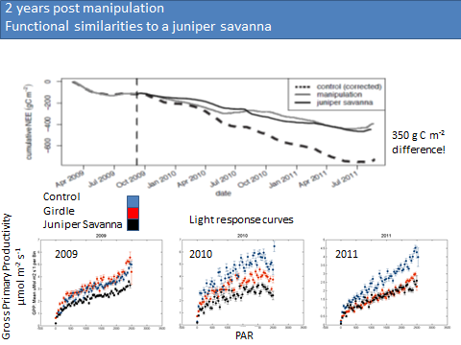
- The decrease in carbon sequestration in the girdled site compared to the control site through July 2012, makes the girdled PJ site functionally similar to a juniper savanna site approximately 25 miles to the east of these two PJ sites in NM (Figure 5). Light response curves in 2009, 2010 and 2011 at all three sites (PJ control, PJ girdle and juniper savanna) confirm that the girdled site in 2011 was functionally more similar to the juniper savanna site than an intact PJ woodland (Figure 5).
Figure 5. The top graph shows cumulative Net Ecosystem Exchange (NEE) curves at control and girdled PJ sites from Feb 2009-Oct 2011, compared to nearby juniper savanna site. Juniper savanna fluxes are from Oct 2009. PJ control fluxes are normalized using regressions discussed in Figure 4. The bottom row of graphs are light response curves for PJ control, girdled and juniper savanna sites in 2009-2011. Both the top and bottom set of graphs show functional similarities of girdled PJ site to the juniper savanna site. These data are crucial for parameterizing land surface models to quantify the regional consequences of widespread piñon mortality.
- Although we added an estimated 216 g C m⁻² in litterfall alone from the dead trees in 2009-2010, the first pulse we observed in ecosystem respiration was following the monsoon precipitation in 2011 (Figure 6). This lag has been noted in other coniferous ecosystems where large mortality events have been observed and is important to note in ecosystem and land surface models trying to quantify the consequences of large scale mortality events.
- In terms of the consequences of widespread piñon mortality on evapotranspiration (ET) from PJ woodlands, we noticed a reduction in ET, but no changes in seasonality (Figure 7).

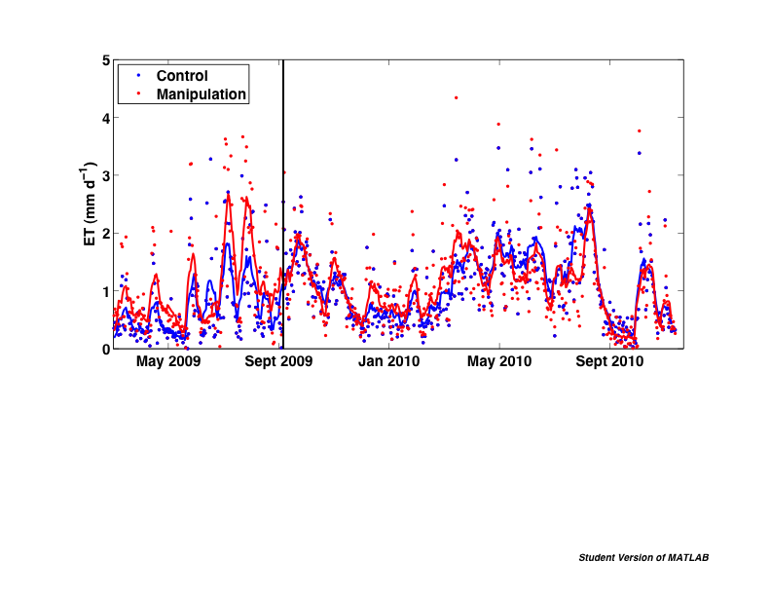
Figure 7. Time series of daily evapotranspiration (ET) measured by the eddy covariance systems at both the PJ control and girdled sites. We have observed a reduction in ET in the girdled site, but no change in overall seasonality of these fluxes in response to the girdling treatment. This suggests ET is primarily responding to the decrease in LAI created by the piñon mortality.
Figure 6. Ratio of ecosystem respiration (Re) to gross primary productivity (GPP) from Feb 2009-Oct 201 in the PJ control and girdled sites. Note the scale change for the last few months of 2011. Following the onset of the 2011 monsoon, we observed a 5 fold greater flux of carbon out, the first indication of decomposition of the dead carbon input to the system in response to the girdling treatment.

C.

Belowground Carbon dynamics -
- In 2011, project work focused on the effects of piñon mortality on belowground carbon and nutrient dynamics using pre-monsoon and post-monsoon soil samples analyzed for C, N and P, microbial enzyme activities and fungal biomass, along transects that connected live junipers to live and dead piñons. The period January to June 2011 was an extreme drought, with virtually no precipitation recorded at the sampling sites, so the pre-monsoon data represent a baseline for minimum microbial activity and biomass. Following monsoon rains, belowground analyses indicate that nutrient and water availabilities under junipers at the girdled site increased as a result of piñon mortality and may help explain why measures of net ecosystem carbon exchange at the piñon mortality site have begun to track patterns observed in the juniper savanna biome.
- In 2012, we collected samples of piñon and juniper roots from the piñon-juniper forest and juniper savanna sites for molecular analysis of root-associated fungal communities. Conifer mortality, wildfire and shrub encroachment are the most conspicuous and widespread climate change related ecosystem changes in the southwestern US. Our analyses measure the short term changes in soil processes that accompany these disturbances. The magnitude and direction of these responses will determine whether sites follow post-disturbance recovery trajectory back to their previous ecosystem states or transition to a new state.
- To explain why we did not observe an immediate increase in soil respiration following our girdling event, we experimentally monitored the response of soil respiration fluxes to water, sucrose and ammonium sulfate solution applications to both the mineral soil and litter surface, using an additional network of 20 automated chambers that measured soil flux at each site in 2011 and 2012. Soil fluxes were limited by water, C, and N in the mineral soil at both the mortality and reference sites (two-way ANOVA; P<0.001 for all comparisons). In addition, we found that soil flux increased more in response to both water and N at the mortality-affected site than at the reference site. In contrast, soil flux responded less to C additions at the mortality-affected site than at the unaltered site. Treatments to the litter surface revealed greater water limitation of soil fluxes at the mortality site but no differences in C or N limitation. We propose that the increase in litterfall C at the mortality site drove the increased response of soil fluxes to water additions. In the mineral soil, N limitation was induced as soil-available N was used by microbes to metabolize the additional litterfall C. We conclude that the soil flux response following mortality is more dependent on soil water and N availability than from non-mortality-affected areas. Thus, soil fluxes in the years after mortality may follow increases in water and N availability.
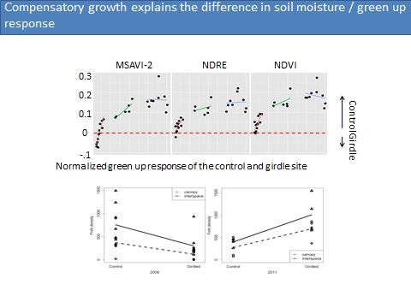
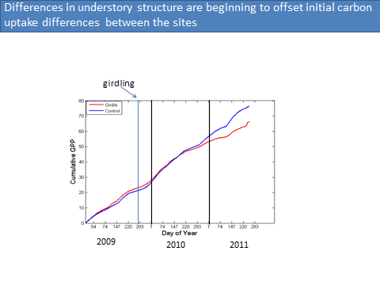
3. Remote sensing
Figure 8. The top row of graphs show normalized difference in three RapidEye derived vegetation indices (MSAVI-2, NDRE, and NDVI) that measure greenness between the PJ control and girdled site in 2009 (red), 2010 (green) and 2011 (blue). Each point is an average of 25 pixels. Negative numbers indicate the girdled site is “greener”, positive numbers indicate the control site is “greener”. The control site is “greener” following the girdling in late 2009, and although stays greener through 2011, the flat slope of the line indicates the response is leveling out in 2011. The bottom two graphs show the increase in forb density in the girdled site in 2011. This increase in understory vegetation under the girdled trees explains the trend in vegetation indices between the sites we observed.
Figure 9. Cumulative Gross Primary Productivity (GPP) in the PJ control and girdled sites from Feb 2009-Oct 2011. We hypothesize that the small increase in the girdled site cumulative GPP curve at the end of 2011 is also due to the increase in understory herbaceous biomass under the girdled piñon trees.

- We used the time series of 22 RapidEye images from prior to girdling in 2009-2011 to detect changes in phenology in the girdled site following the girdling. Using change detection techniques, we identified (and verified with ground truthing) over 200 5x5 m pixels under dead piñon trees in the girdled site, and compared three vegetation indices in these pixels to pixels of healthy piñons in the control site. The difference in these two time series clearly reflects the decrease in LAI in the girdled site following the girdling treatment (Figure 8). Although the control site is “greener” overall in 2011, the decrease in change between the two sites is likely due to the increase in herbaceous biomass in the girdled site, which was verified by field plot measurements (Figure 8). The difference in ecosystem structure as the herbaceous understory grows in the girdled site is starting to be reflected in ecosystem process measurements such as GPP (Figure 9).
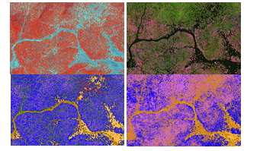
- We are now combining our RapidEye time series with multi-temporal WorldView-2 multispectral data and full waveform aerial lidar data acquired within a month of each other in 2011 to more accurately describe ecosystem structural components in the two sites and quantify carbon offsets due to the changes we observe in structural classifications (Figure 10). These structural data and observations from the tower sites are being used to parameterize the Community Land Model (CLM) to quantify the consequences of widespread piñon mortality for regional carbon dynamics and climate.
Figure 10. False color composites of study region south of Mountainair, NM the includes both PJ control and girdled sites we are using to classify semi-arid PJ woodlands. These images (top row) are comparing WorldView-2 satellite data (WV2) (left - NDVI, Red Edge, Yellow) and Lidar (right - Height, Rise Time, Energy Ratio) feature separability. The resulting classifications (bottom row) illustrate the strengths and weaknesses of both platforms. WV2 is better able to delineate grass classes, while the waveform products due a better job with understory components.

7. A list of papers (already published, in press, submitted) in which DOE support is acknowledged.
Eitel, J.U.H., L. A. Vierling, M.E. Litvak, D. Krofcheck, D.S. Long, A.A. Ager, A. Hudak
and L. Stoscheck. 2011. Broadband, red-edge information from satellites improves
early stress detection in conifer forests. Remote Sensing doi:10.1016/ j.rse.2011.09.002
Berryman, E.M, Marhsall, J.D., Rahn, T., Cook, S.P. and Litvak, M. 2011. Adaptation of
continuous-flow cavity ring-down spectroscopy (CRDS) for batch analysis of δ¹³C of CO₂. Rapid Communications in Mass Spectrometry 16:2355-60.
Eitel, J.U.H., L.A. Vierling, D.S. Long, M. Litvak, K.B. Eitel. 2011Simple assessment of
needleleaf and broadleaf chlorophyll content using a flatbed color scanner.
Can J For Res 41:1445-1451.
Anderson-Teixera, K. J., DeLong J. P., Fox, A. M., Brese, D. and Litvak, M. E., 2011. Climate change will reduce the capacity of Southwest ecosystems to sequester and store carbon. Global Change Biology 17, 410-424.
Berryman, E.M., J.D. Marshall, T. Rahn, M.E. Litvak and J. Butnor. Decreased carbon limitation of litter respiration in a mortality-affected piñon-juniper woodland. (in review) Biogeosciences.
Krofcheck, D., J. Eitel, L. Vierling, U. Schulthess, E. Robinson and M.E. Litvak. Assessing
ecosystem function of a Piñon-Juniper woodland using a time series of high resolution satellite imagery and eddy covariance measurements. (in review) Remote Sensing.
Krofcheck, D., J. Eitel, L. Vierling, U. Schulthess, E. Robinson and M.E. Litvak. Linking
structural and functional changes of a semi-arid woodland in Central New Mexico using a time-series of high resolution satellite imagery and eddy covariance measurements. (in review) Remote Sensing of the Environment.
Fox, A.M, T. Hilton, R.L. Sinsabaugh, N. McDowell, T. Rahn and M.E. Litvak. Quantifying the transient
dynamics of ecosystem-scale carbon cycle responses to piñon-pine mortality using a large scale experimental manipulation and model-data fusion (in review) Global Change Biology.

8. A list of people who worked on the project – graduate students, postdocs, visitors, technicians, etc. Indicate for each whether receiving full or partial support. In case of partial support indicate percentage of support.
Andy Fox – postdoc 100% support, 2 years
Tim Hilton – postdoc 100% support, 8 mos.
Mike Fuller – postdoc 25% support, 3 mos.
Chris Bickford – postdoc 25% support, 8 mos.
Sarah Hicks – technician 100% support, 6 mos.
Virginie Ponteau - technician - 50% support, 4 mos
Emma Elliot Smith - undergraduate field assistant, 3 summers
Cecilia Payan – undergraduate field assistant, 1 summer
Sabrina McNew – undergraduate field assistant, 1 summer, full time
Kelly Williamson – undergraduate field assistant, 2 summers, full time
Thommy Thompson, Gaea McGahee, field assistants – 2 summers, 50% time
Dan Krofcheck, Amanda Liebricht – grad students, 2 summers, 2 semesters each
Leo Stoscheck – technician 50% support – 3 years
Erin Berryman - visiting graduate student from Idaho State University, no support

9. Other support

Improving the estimation of carbon stocks and fluxes in semi-arid ecosystems of the southwestern US using full-waveform lidar measurements. M. Litvak (PI), A. Neuwenschwander- PI, A. Fox, J. Heilman. NASA – ROSES, Carbon cycle processes,
start date 5/1/2011. $1,338,361. This grant paid for the airborne lidar we will use to quantify and describe ecosystem structure in the PJ sites.

Determining the impact of forest mortality in semi-arid woodlands on local and regional carbon dynamics. M. Litvak (PI), R.L. Sinsabaugh, A. Fox, N. McDowell. DOE BER. Start date 7/1/2012. $1,049,130. This grant just started this summer and is essentially a continuation of the DOE-EPSCoR award. We will characterize the carbon pools in the system, quantify rates of decomposition and controls over decomposition, and modify CLM to estimate regional consequences of widespread coniferous mortality events.

10. Budget, see attached spreadsheet.

